**9. Create a React Application named “cricketapp”**

**Code:**

import React from 'react';

function App() {

const flag = true;

const players = [

{ name: 'Virat', score: 80 },

{ name: 'Rohit', score: 60 },

{ name: 'KL Rahul', score: 75 },

{ name: 'Pant', score: 65 },

{ name: 'Bumrah', score: 50 },

{ name: 'Shami', score: 70 },

{ name: 'Siraj', score: 45 },

{ name: 'Jadeja', score: 85 },

{ name: 'Ashwin', score: 40 },

{ name: 'Gill', score: 95 },

{ name: 'Hardik', score: 55 }

];

const highScorers = players.filter(player => player.score >= 70);

const lowScorers = players.filter(player => player.score < 70);

const oddPlayers = ['Virat', 'KL Rahul', 'Bumrah', 'Shami', 'Jadeja'];

const evenPlayers = ['Rohit', 'Pant', 'Siraj', 'Ashwin', 'Gill', 'Hardik'];

const [v1, v2, v3, v4, v5] = oddPlayers;

const [e1, e2, e3, e4, e5, e6] = evenPlayers;

const T20Players = ['Virat', 'Rohit', 'Pant'];

const RanjiPlayers = ['Pujara', 'Rahane', 'Ishant'];

const mergedPlayers = [...T20Players, ...RanjiPlayers];

return (

<div style={{ padding: '20px', fontFamily: 'Arial' }}>

<h1>Welcome to Cricket App</h1>

{flag ? (

<>

<h2>All Players</h2>

<ul>

{players.map((p, i) => (

<li key={i}>{p.name} - {p.score}</li>

))}

</ul>

<h3>Filtered Players (Score ≥ 70)</h3>

<ul>

{highScorers.map((p, i) => (

<li key={i}>{p.name} - {p.score}</li>

))}

</ul>

<h3>Filtered Players (Score < 70)</h3>

<ul>

{lowScorers.map((p, i) => (

<li key={i}>{p.name} - {p.score}</li>

))}

</ul>

</>

) : (

<>

<h2>Odd Team Players (Destructured)</h2>

<ul>

<li>{v1}</li>

<li>{v2}</li>

<li>{v3}</li>

<li>{v4}</li>

<li>{v5}</li>

</ul>

<h2>Even Team Players (Destructured)</h2>

<ul>

<li>{e1}</li>

<li>{e2}</li>

<li>{e3}</li>

<li>{e4}</li>

<li>{e5}</li>

<li>{e6}</li>

</ul>

<h2>Merged Players (T20 + Ranji)</h2>

<ul>

{mergedPlayers.map((p, i) => (

<li key={i}>{p}</li>

))}

</ul>

</>

)}

</div>

);

}

export default App;

**Output:**

**Flag=true:**

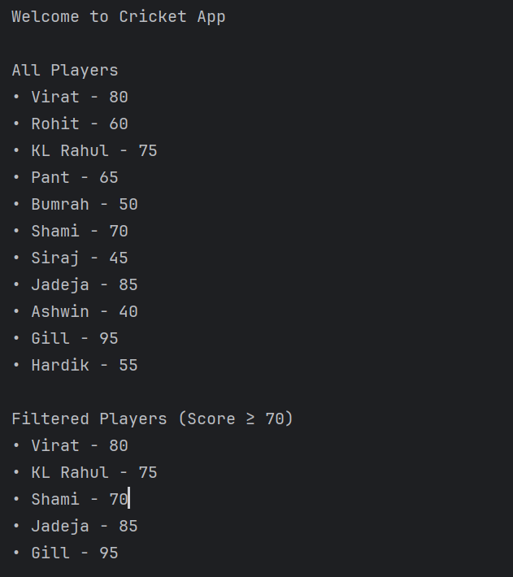

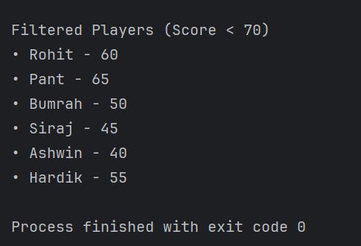

**Flag=false:**

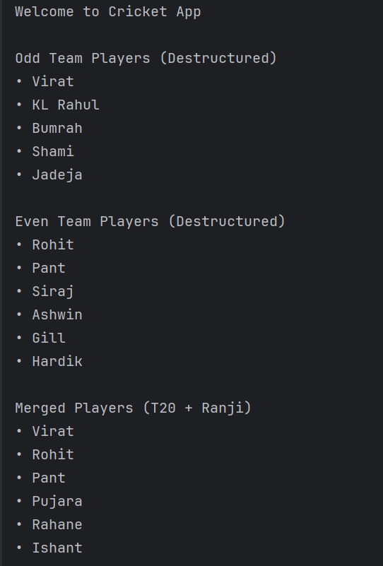

**10.** **Create a React Application named “officespacerentalapp” which uses React JSX to create elements, attributes and renders DOM to display the page**

**Code:**

import React from 'react';

function App() {

const heading = <h1>Office Space Rental App</h1>;

const imageStyle = {

width: '300px',

height: '200px',

borderRadius: '10px',

marginBottom: '10px'

};

const officeList = [

{

name: 'Downtown HQ',

rent: 75000,

address: '12 Main Street, Bangalore',

image: 'https://via.placeholder.com/300x200?text=Office+1'

},

{

name: 'Startup Hub',

rent: 55000,

address: '88 Tech Park, Hyderabad',

image: 'https://via.placeholder.com/300x200?text=Office+2'

},

{

name: 'Elite Workspace',

rent: 92000,

address: '5 MG Road, Mumbai',

image: 'https://via.placeholder.com/300x200?text=Office+3'

}

];

return (

<div style={{ padding: '20px', fontFamily: 'Arial' }}>

{heading}

{officeList.map((office, index) => (

<div

key={index}

style={{

border: '1px solid #ccc',

padding: '15px',

marginBottom: '20px',

borderRadius: '10px'

}}

>

<img src={office.image} alt={office.name} style={imageStyle} />

<h2>{office.name}</h2>

<p>

<strong>Rent: </strong>

<span

style={{

color: office.rent < 60000 ? 'red' : 'green',

fontWeight: 'bold'

}}

>

₹{office.rent}

</span>

</p>

<p>

<strong>Address: </strong>{office.address}

</p>

</div>

))}

</div>

);

}

export default App;

**Output:**

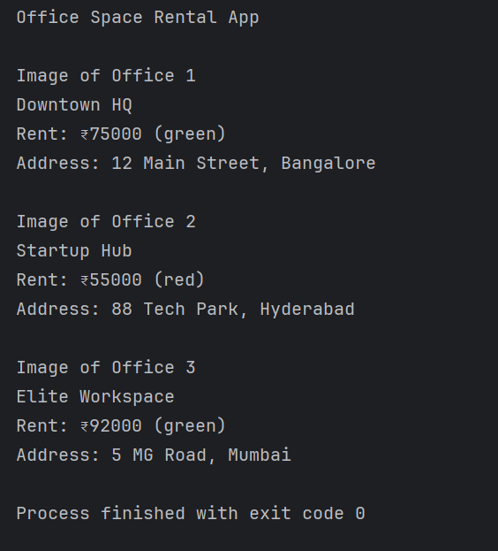

**11.** **Create a React Application “eventexamplesapp” to handle various events of the form elements in HTML**

**Code:**

import React, { Component } from 'react';

class App extends Component {

constructor(props) {

super(props);

this.state = {

count: 0,

rupees: '',

euros: ''

};

this.handleIncrement = this.handleIncrement.bind(this);

this.sayHello = this.sayHello.bind(this);

this.handleSubmit = this.handleSubmit.bind(this);

}

handleIncrement() {

this.setState(prevState => ({ count: prevState.count + 1 }));

this.sayHello(); // Call multiple methods

}

sayHello() {

console.log("Hello! Have a great day!");

}

handleDecrement = () => {

this.setState(prevState => ({ count: prevState.count - 1 }));

};

sayWelcome(message) {

alert("Say " + message);

}

handleSyntheticEvent = (e) => {

alert("I was clicked");

console.log("SyntheticEvent: ", e);

};

handleSubmit(e) {

e.preventDefault();

const euros = (parseFloat(this.state.rupees) / 90).toFixed(2);

this.setState({ euros });

}

render() {

return (

<div style={{ padding: '20px', fontFamily: 'Arial' }}>

<h2>React Event Handling Examples</h2>

<h3>Counter: {this.state.count}</h3>

<button onClick={this.handleIncrement}>Increment</button>{' '}

<button onClick={this.handleDecrement}>Decrement</button>

<br /><br />

<button onClick={() => this.sayWelcome("Welcome")}>Say Welcome</button>

<br /><br />

<button onClick={this.handleSyntheticEvent}>Synthetic Event (onClick)</button>

<br /><br />

<h3>Currency Converter (INR → Euro)</h3>

<form onSubmit={this.handleSubmit}>

<input

type="number"

placeholder="Enter amount in ₹"

value={this.state.rupees}

onChange={(e) => this.setState({ rupees: e.target.value })}

/>{' '}

<button type="submit">Convert</button>

</form>

{this.state.euros && (

<p>Converted Amount: €{this.state.euros}</p>

)}

</div>

);

}

}

export default App;

**Output:**

**Currency Converter:**

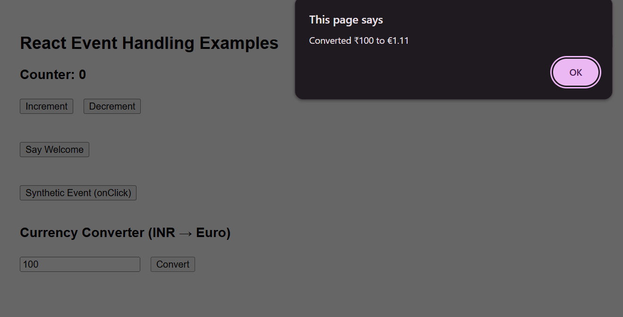

**Increment:**

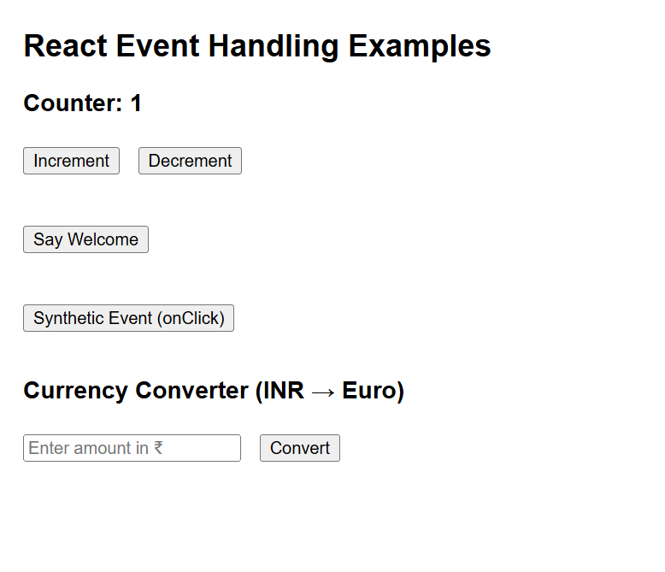

**Decrement:**

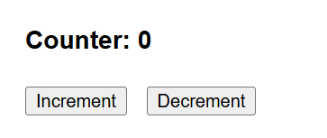

**Say Welcome:**

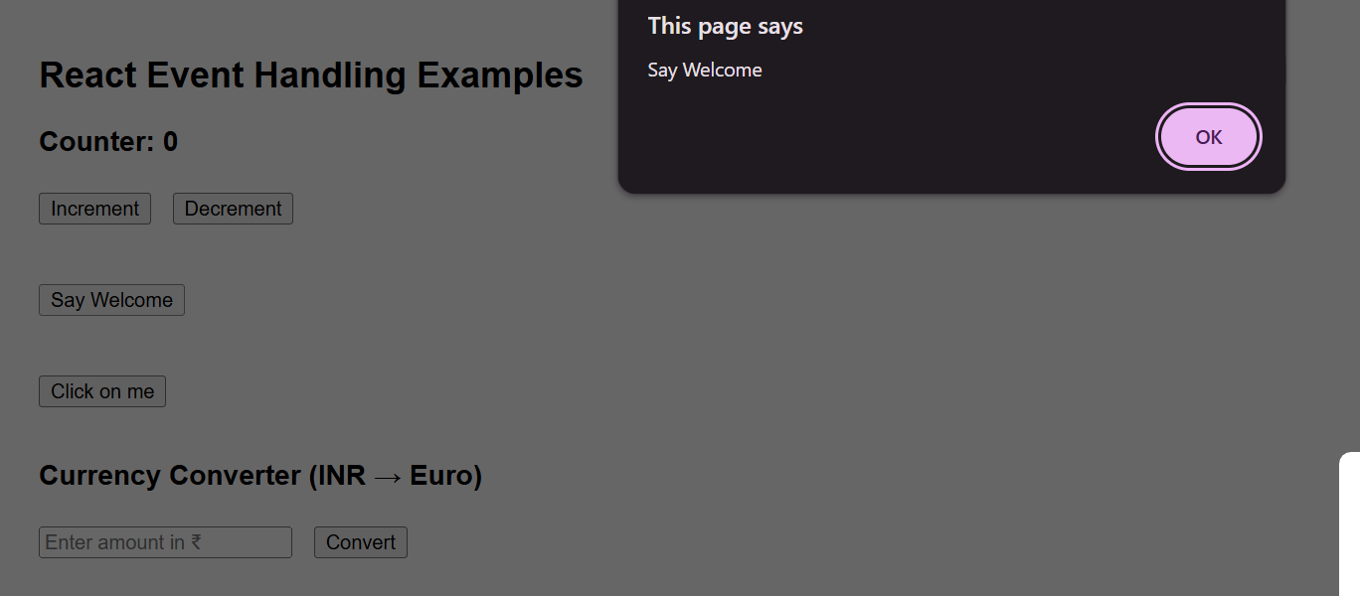

**Click on me:**

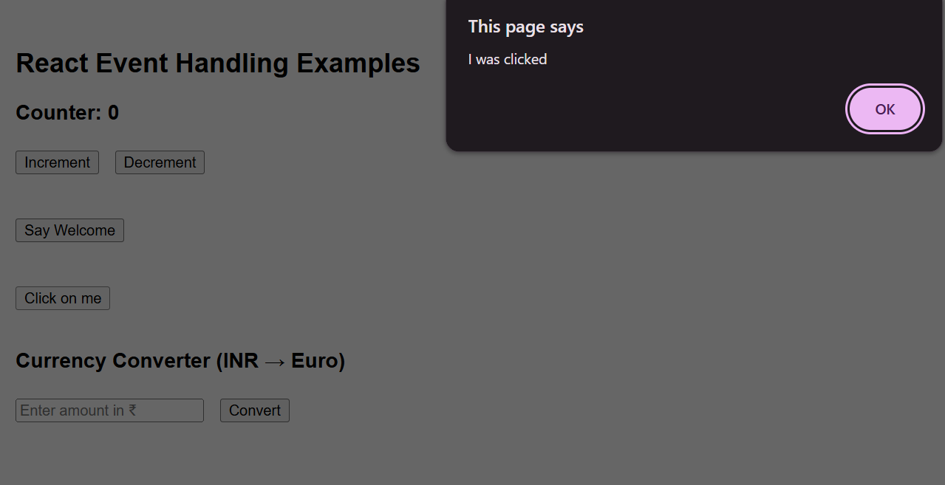

**12. Create a React Application named “ticketbookingapp” where the guest user can browse the page where the flight details are displayed whereas the logged in user only can book tickets**

**Code:**

import React, { useState } from 'react';

function App() {

const [isLoggedIn, setIsLoggedIn] = useState(false);

const handleLogin = () => setIsLoggedIn(true);

const handleLogout = () => setIsLoggedIn(false);

const GuestPage = () => (

<div>

<h2>Welcome Guest</h2>

<p>Here are the available flight details:</p>

<ul>

<li>Flight: AI202 | From: Delhi | To: Mumbai | Time: 10:00 AM</li>

<li>Flight: AI303 | From: Bangalore | To: Chennai | Time: 2:00 PM</li>

</ul>

<p>Please log in to book your tickets.</p>

</div>

);

const UserPage = () => (

<div>

<h2>Welcome User</h2>

<p>You are now logged in. You can book your flight tickets below:</p>

<ul>

<li>Flight: AI202 | <button>Book Now</button></li>

<li>Flight: AI303 | <button>Book Now</button></li>

</ul>

</div>

);

const pageToDisplay = isLoggedIn ? <UserPage /> : <GuestPage />;

return (

<div style={{ padding: '20px', fontFamily: 'Arial' }}>

<h1>Ticket Booking App</h1>

{isLoggedIn ? (

<button onClick={handleLogout}>Logout</button>

) : (

<button onClick={handleLogin}>Login</button>

)}

<hr />

{pageToDisplay}

</div>

);

}

export default App;

**Output:**

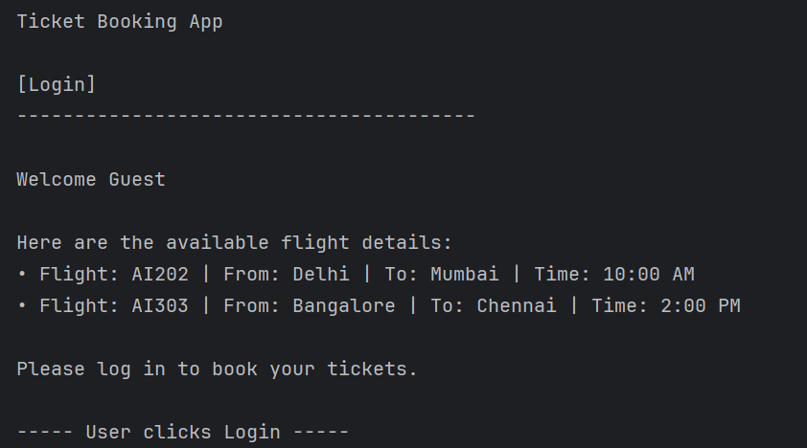

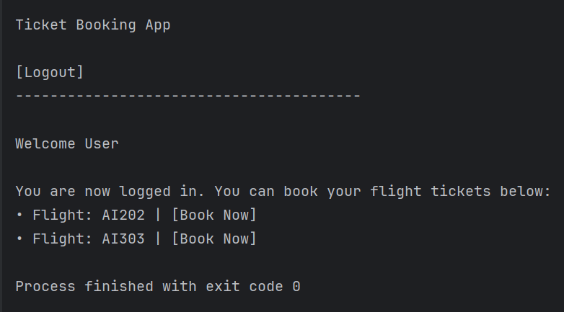

**13.** **Create a React App named “bloggerapp”**

**Code:**

import React, { useState } from 'react';

function App() {

const [view, setView] = useState("book");

const [showCourse, setShowCourse] = useState(true);

let content;

if (view === "book") {

content = <BookDetails />;

} else if (view === "blog") {

content = <BlogDetails />;

}

return (

<div style={{ padding: '20px', fontFamily: 'Arial' }}>

<h1>Blogger App</h1>

{/* Button Navigation */}

<button onClick={() => setView("book")}>Show Book</button>

<button onClick={() => setView("blog")}>Show Blog</button>

<button onClick={() => setView("course")}>Show Course</button>

<button onClick={() => setShowCourse(!showCourse)}>

Toggle Course Details (&& Render)

</button>

<hr />

{/* 1. Rendering using Element Variable */}

{content}

{/* 2. Ternary Operator for BlogDetails if not already handled above */}

{view === "blog" ? <BlogDetails /> : null}

{/* 3. If/Else block already handled above */}

{/* 4. Short-circuit Rendering */}

{view === "course" && <CourseDetails />}

{showCourse && <CourseDetails />}

</div>

);

}

function BookDetails() {

const books = [

{ id: 1, title: "React Basics", author: "Dan Abramov" },

{ id: 2, title: "Learning JSX", author: "Sophie Alpert" }

];

return (

<div>

<h2>Book Details</h2>

<ul>

{books.map((book) => (

<li key={book.id}>{book.title} - {book.author}</li>

))}

</ul>

</div>

);

}

function BlogDetails() {

const blogs = [

{ id: 101, title: "React vs Angular" },

{ id: 102, title: "Why JSX Matters" }

];

return (

<div>

<h2>Blog Details</h2>

<ul>

{blogs.map((blog) => (

<li key={blog.id}>{blog.title}</li>

))}

</ul>

</div>

);

}

function CourseDetails() {

return (

<div>

<h2>Course Details</h2>

<p>Course: Full Stack Web Development</p>

<p>Duration: 3 Months</p>

</div>

);

}

export default App;

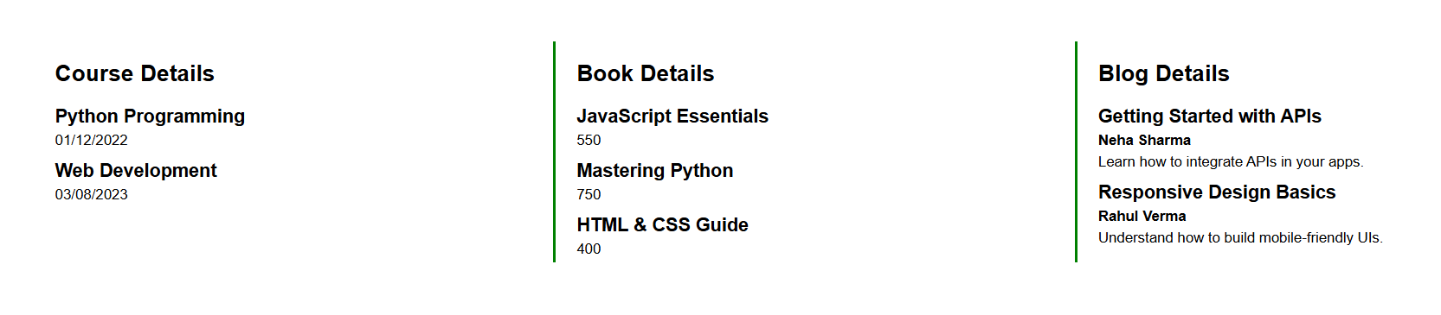**Output:**